**SDET Software Installation Process:**

**JAVA 🡺 1.8.291**

**Installation step:-**

**Step1:-** Uninstall the java if you have older/other version java in control panel

**Step2:-** Download the java 1.8.291 from official website or RMG google drive

<https://drive.google.com/drive/folders/1cxQXtR70rJHLmG1eneIwyuHNFikcOcuV>

**Step3:-** Navigate the downloaded file and double click on java.exe 🡪 click on next, next, next🡪 close

**Step4:-** Navigate **C:\Program Files\Java** and make sure that whether we have jdk and jre in same version and build number

1. Click **Next** to proceed to the next step.

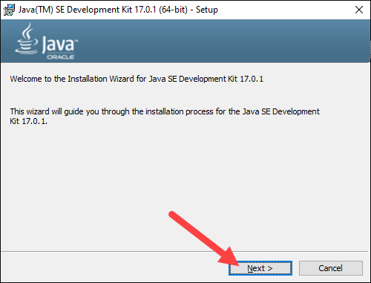

2. Choose the destination folder for the Java installation files or stick to the default path. Click **Next**to proceed.

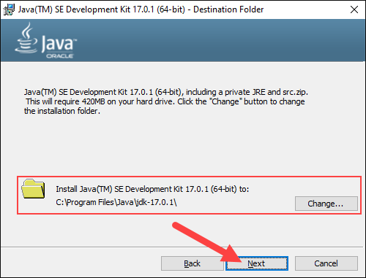

3. Wait for the wizard to finish the installation process until the *Successfully Installed* message appears. Click **Close** to exit the wizard.

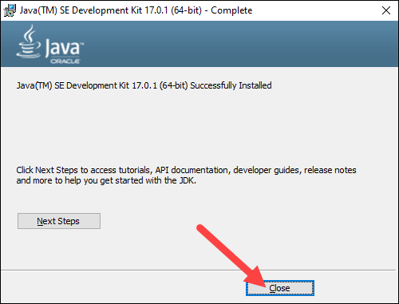

**Disable java updates**

Step:- open Task Manager 🡪 navigate startup tab 🡪 disable **java update scheduler**

**Set Environmental Variables in Java**

**Set path of java in windows:-**

Navigate C:\Program Files\Java\jdk1.8.0_291\bin folder and copy the path

Right click on **This PC ,** click on **properties**

Click on **Advanced system settings**

Click on **Environment variables**

In the **Uservariable 🡪** click on new 🡪 enter **JAVA_HOME** variable_name🡪 enter **C:\Program Files\Java\jdk1.8.0_291** variable_value

In the **Systemvariable 🡪** search **path** variable 🡪click on edit 🡪 click on new🡪 enter **C:\Program Files\Java\jdk1.8.0_291\bin**

Click on **ok , ok, ok**

**Add Java to System Variables**

1. Open the **Start** menu and search for *environment variables*.

2. Select the **Edit the system environment variables** result.

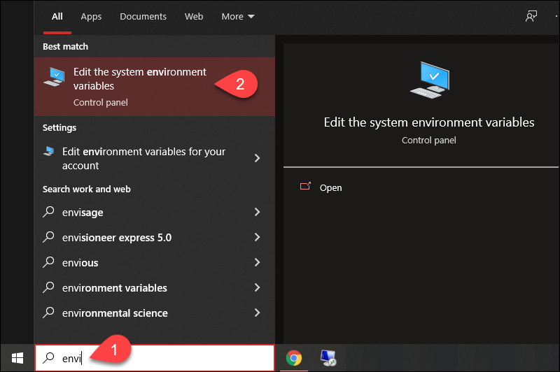

3. In the *System Properties* window, under the *Advanced*tab, click **Environment Variables…**

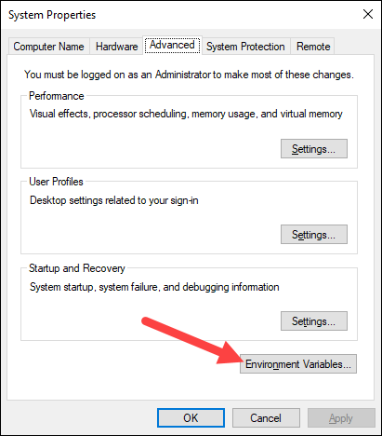

4. Under the *System variables* category, select the **Path**variable and click **Edit**:

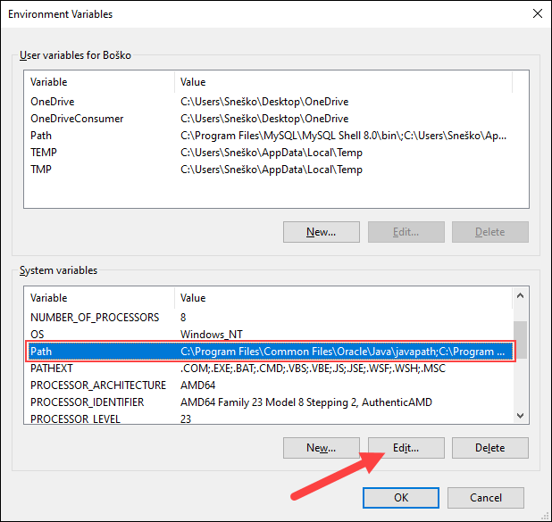

5. Click the **New** button and enter the path to the Java bin directory:

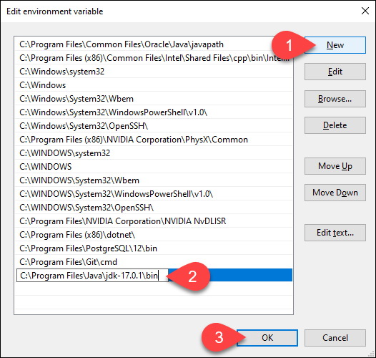

**Note:** The default path is usually *C:\Program Files\Java\jdk-17.0.1\bin*.

6. Click **OK** to save the changes and exit the variable editing window.

**Step 2: Add JAVA_HOME Variable**

Some applications require the **JAVA_HOME** variable. Follow the steps below to create the variable:

1. In the *Environment Variables* window, under the *User variables*category, click the **New…** button to create a new variable.

2. Name the variable as ***JAVA_HOME***.

3. In the variable value field, paste the path to your Java jdk directory and click **OK**.

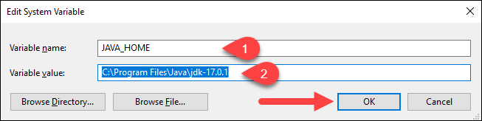

4. Confirm the changes by clicking **OK** in the *Environment Variables* and *System properties* windows.

**Make sure wheather java installed or not:-**

Open fresh instance of command prompt 🡪 type **java -version**

## Test the Java Installation

Run the **java -version** command in the command prompt to make sure Java installed correctly:

